**Globetrotter**

* For my grad project, I will be adding a log in functionality for the user which will mostly be either through facebook or google.
* I plan to use firebase to help with the storage of the data as realm takes up quite a bit of memory. This will involve quite a bit of re-writing of the app as I will have to change all the saving of data from realm to firebase.

**Mockups:**

Log in Page:

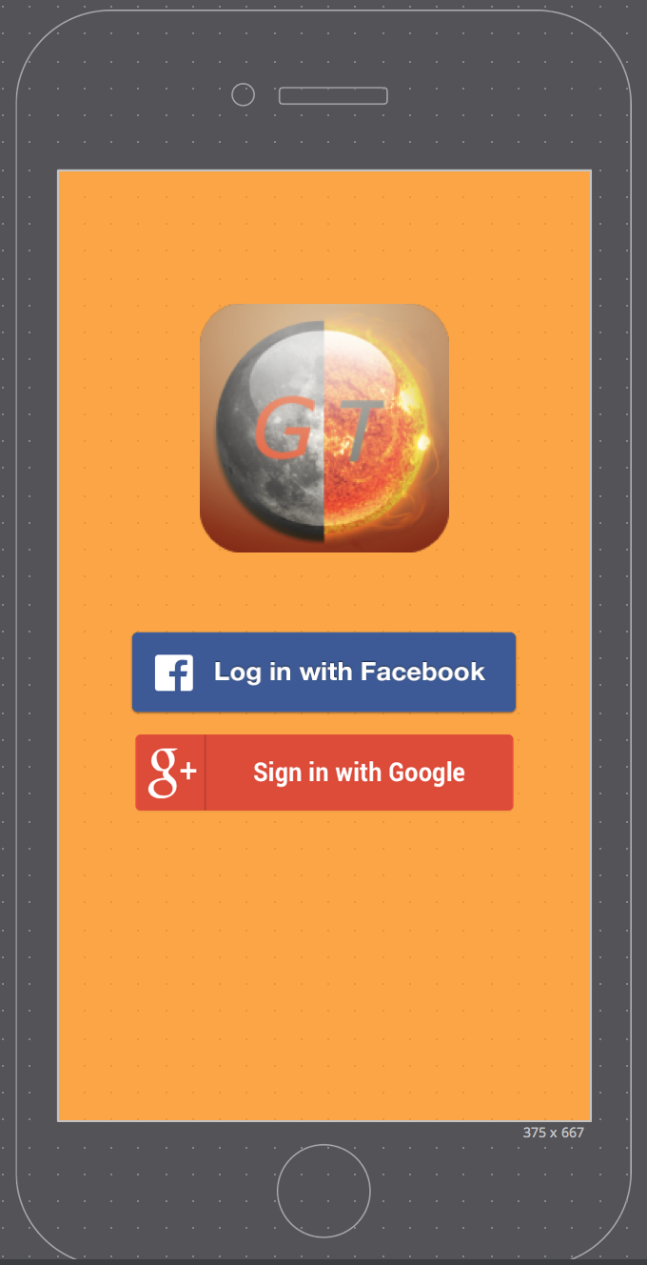

NOTE: I have not mocked up a page for the sharing as I haven’t yet looked into it and so am not sure as to what options are required and how it should be laid out for the user.

**Mockups (same as for iOS project) :**

1. This will be the launch screen for the app

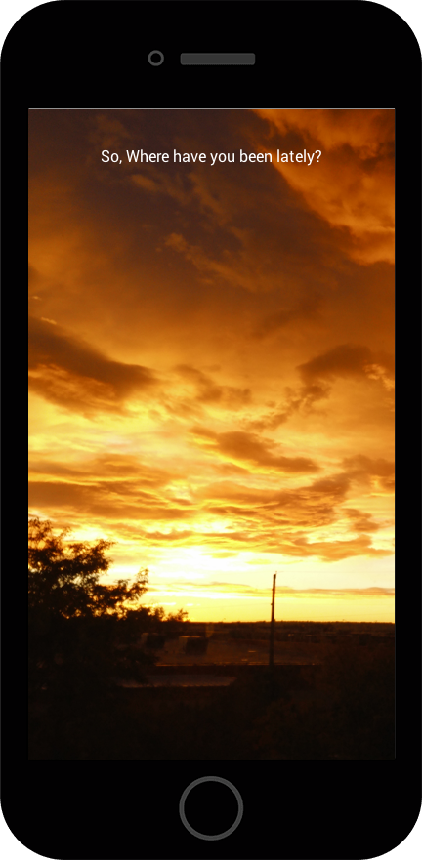

1. This will be a list of the places entered by the user. On the left will be a thumbnail image of each place that the user has chosen. The text will be the name of each place that the user has entered. The top left is a search icon which allows the user to search for a place. The top right is a button which allows the user to add a new place.

PS: Was not able to mockup a tableview, however, the name of the places and the images will be displayed in a table view.

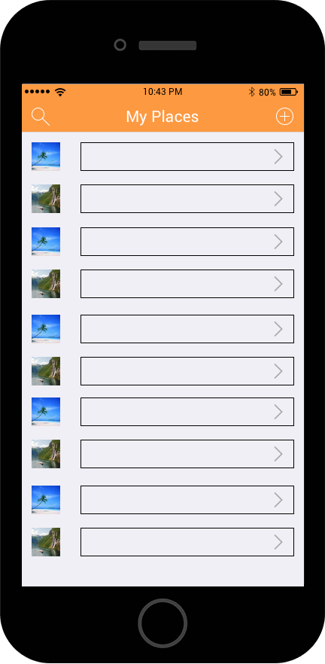

1. When the user taps the add button, they can enter a new place. The enter the name of the place along with a brief description on what they loved about that place. The user can then navigate to select an image of that place. This image will be used as the thumbnail image in screen 2

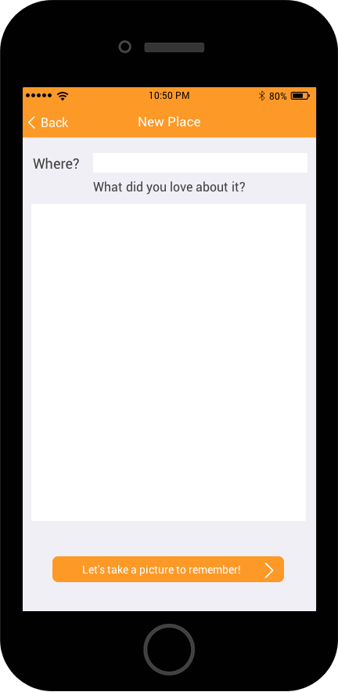

1. This page allows a user to either take a picture by clicking on the camera icon or by selecting a previously taken image from their gallery which will then be displayed to the user in the image view.

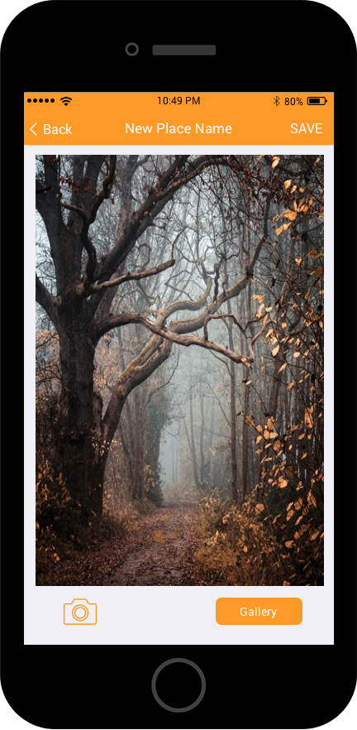

1. If the user taps on a cell instead of the add button, then they are taken to the same screens. Screen 3 will have the input text fields already filled but the user can edit them. Same applies to the image which will already be displayed.